Feedback: Functional Model
Project Title: AI based Academic Expense & Loan Planner
By
Chaitanya Raj Kolipaka

1. Use Case Diagram
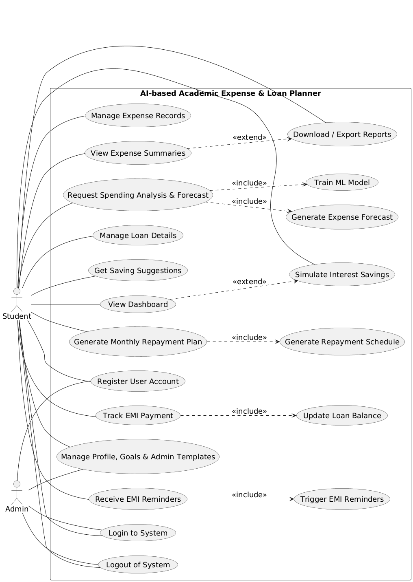
Figure.1 Use Case Diagram

2. Use Case Description
Use Case Name: Use Case 1: Register User Account
ID: UC-01
Importance Level: High
Primary Actor: Student, Admin
Use Case Type: Primary
Stakeholders and Interests:
Students and Admins want to create an account to access and manage academic expenses and loan planning features securely.
Brief Description:
This use case allows a student or admin to create a new user account in the system using basic registration details.
Trigger:
User selects the register option on the system home page.
Type:
User-initiated
Relationships:
Association: Student, Admin
Include: None
Extend: None
Generalization: None
Normal Flow of Events:
- The user opens the registration page.
- The user enters name, email, and password.
- The system validates the entered details.
- The system creates the user account.
- The system confirms successful registration.
SubFlows:
S-1: If input validation is successful, the system proceeds to create the account.
Alternate/Exceptional Flows:
If required fields are missing, the system shows an error message.
If the email already exists, the system asks the user to use a different email.
Related Functional Requirements:
1, 2

Use Case Name: Use Case 2: Login to System
ID: UC-02
Importance Level: High
Primary Actor: Student, Admin
Use Case Type: Primary
Stakeholders and Interests:
Students and Admins want secure access to the system to manage expenses, loans, and reports.
Brief Description:
This use case allows registered users to log in using valid credentials.
Trigger:
User selects the login option.
Type:
User-initiated
Relationships:
Association: Student, Admin
Include: None
Extend: None
Generalization: None
Normal Flow of Events:
- The user enters email and password.
- The system validates the credentials.
- The system grants access to the dashboard.
SubFlows:
S-1: If credentials are valid, the system creates a session.
Alternate/Exceptional Flows:
If credentials are invalid, the system shows an error message.
If too many failed attempts occur, the account is locked.
Related Functional Requirements:
3, 4

Use Case Name: Use Case 3: Logout of System
ID: UC-03
Importance Level: Medium
Primary Actor: Student, Admin
Use Case Type: Primary
Stakeholders and Interests:
Users want to securely end their session after using the system.
Brief Description:
This use case allows users to log out of the system securely.
Trigger:
User selects the logout option.
Type:
User-initiated
Relationships:
Association: Student, Admin
Include: None
Extend: None
Generalization: None
Normal Flow of Events:
- The user clicks the logout button.
- The system clears the active session.
- The system redirects the user to the login page.
SubFlows:
S-1: The system ends the session and clears session data.
Alternate/Exceptional Flows:
If the session has expired, the system logs out the user automatically.
Related Functional Requirements:
5, 6

Use Case Name: Use Case 4: Manage Expense Records
ID: UC-04
Importance Level: High
Primary Actor: Student
Use Case Type: Primary
Stakeholders and Interests:
Students want to add, edit, and remove their expense records to track spending accurately.
Brief Description:
This use case allows students to manage tuition, accommodation, and personal expense records.
Trigger:
Student selects add, edit, or delete expense option.
Type:
User-initiated
Relationships:
Association: Student
Include: None
Extend: None
Generalization: None
Normal Flow of Events:
- The student opens the expense management page.
- The student enters or updates expense details.
- The system validates the data.
- The system saves the changes.
- The system confirms the update.
SubFlows:
S-1: The system stores the expense data in the database.
Alternate/Exceptional Flows:
If invalid values are entered, the system asks the student to correct them.
Related Functional Requirements:
7, 8, 10, 11, 12, 52

Use Case Name: Use Case 5: View Expense Summaries
ID: UC-05
Importance Level: Medium
Primary Actor: Student
Use Case Type: Primary
Stakeholders and Interests:
Students want to view monthly and yearly summaries to understand spending.
Brief Description:
This use case displays summarized expense information for selected periods.
Trigger:
Student selects monthly or yearly summary option.
Type:
User-initiated
Relationships:
Association: Student
Include: None
Extend: None
Generalization: None
Normal Flow of Events:
- The student selects month or year view.
- The system aggregates expense records.
- The system displays the summary.
SubFlows:
S-1: The system calculates totals from stored data.
Alternate/Exceptional Flows:
If no expense data exists, the system shows an empty summary message.
Related Functional Requirements:
13, 14, 15, 16

Use Case Name: Use Case 6: Request Spending Analysis and Forecast
ID: UC-06
Importance Level: High
Primary Actor: Student
Use Case Type: Primary
Stakeholders and Interests:
Students want analysis and predictions to manage spending better.
Brief Description:
This use case allows students to request AI-based spending analysis and forecasts.
Trigger:
Student selects spending analysis option.
Type:
User-initiated
Relationships:
Association: Student
Include: None
Extend: None
Generalization: None
Normal Flow of Events:
- The student selects months for analysis.
- The system collects historical expense data.
- The system runs the ML model.
- The system displays forecast results.
SubFlows:
S-1: The system prepares data for the ML model.
Alternate/Exceptional Flows:
If insufficient data exists, the system asks the student to add more records.
Related Functional Requirements:
17, 18, 19, 20, 21, 22

Use Case Name: Use Case 7: Manage Loan Details
ID: UC-07
Importance Level: High
Primary Actor: Student
Use Case Type: Primary
Stakeholders and Interests:
Students want to manage loan details and view loan duration.
Brief Description:
This use case allows students to add and update loan details.
Trigger:
Student selects loan details option.
Type:
User-initiated
Relationships:
Association: Student
Include: None
Extend: None
Generalization: None
Normal Flow of Events:
- The student enters loan amount, EMI, and interest rate.
- The system validates the values.
- The system saves the loan details.
- The system displays estimated loan duration.
SubFlows:
S-1: The system calculates loan duration.
Alternate/Exceptional Flows:
If values are invalid, the system asks the student to correct them.
Related Functional Requirements:
9, 23, 24

Use Case Name: Use Case 8: Get Saving Suggestions
ID: UC-08
Importance Level: Medium
Primary Actor: Student
Use Case Type: Primary
Stakeholders and Interests:
Students want personalized saving suggestions to reduce expenses.
Brief Description:
This use case provides saving tips based on spending patterns.
Trigger:
Student selects saving suggestions option.
Type:
User-initiated
Relationships:
Association: Student
Include: None
Extend: None
Generalization: None
Normal Flow of Events:
- The student opens saving suggestions page.
- The system analyzes spending patterns.
- The system displays saving suggestions.
SubFlows:
S-1: The system uses prediction results to generate suggestions.
Alternate/Exceptional Flows:
If analysis data is missing, the system asks the student to run analysis first.
Related Functional Requirements:
27, 28

Use Case Name: Use Case 9: View Dashboard
ID: UC-09
Importance Level: High
Primary Actor: Student
Use Case Type: Primary
Stakeholders and Interests:
Students want to track loan balance, interest saved, and progress in one place.
Brief Description:
This use case shows the main dashboard with loan and expense progress.
Trigger:
Student opens dashboard page.
Type:
User-initiated
Relationships:
Association: Student
Include: None
Extend: None
Generalization: None
Normal Flow of Events:
- The student opens the dashboard.
- The system calculates balances and progress.
- The system displays charts and values.
SubFlows:
S-1: The system updates dashboard values from stored data.
Alternate/Exceptional Flows:
If some data is missing, the system displays partial information.
Related Functional Requirements:
35, 36, 37, 38, 39, 40

Use Case Name: Use Case 10: Generate Monthly Repayment Plan
ID: UC-10
Importance Level: High
Primary Actor: Student
Use Case Type: Primary
Stakeholders and Interests:
Students want a clear monthly repayment plan to manage loans better.
Brief Description:
This use case generates a personalized monthly repayment plan.
Trigger:
Student selects generate repayment plan option.
Type:
User-initiated
Relationships:
Association: Student
Include: None
Extend: None
Generalization: None
Normal Flow of Events:
- The student requests a repayment plan.
- The system reads loan and expense data.
- The system generates a monthly plan.
- The system displays the plan.
SubFlows:
S-1: The system calculates repayment values.
Alternate/Exceptional Flows:
If loan details are missing, the system asks the student to update loan information.
Related Functional Requirements:
29, 30

Use Case Name: Use Case 11: Track EMI Payment
ID: UC-11
Importance Level: High
Primary Actor: Student
Use Case Type: Primary
Stakeholders and Interests:
Students want to record EMI payments to keep loan balances updated.
Brief Description:
This use case allows students to mark EMI payments as paid.
Trigger:
Student selects mark EMI as paid option.
Type:
User-initiated
Relationships:
Association: Student
Include: None
Extend: None
Generalization: None
Normal Flow of Events:
- The student opens EMI payment section.
- The student selects the EMI and confirms payment.
- The system records the payment.
- The system updates the loan balance.
- The system confirms the update.
SubFlows:
S-1: The system updates loan balance after payment.
Alternate/Exceptional Flows:
If payment details are missing, the system asks the student to enter required details.
If update fails, the system shows an error message.
Related Functional Requirements:
31, 32

Use Case Name: Use Case 12: Receive EMI Reminders
ID: UC-12
Importance Level: High
Primary Actor: Student
Use Case Type: Primary
Stakeholders and Interests:
Students want reminders to avoid missing EMI due dates.
Brief Description:
This use case sends reminder notifications for upcoming EMI payments.
Trigger:
EMI due date is approaching.
Type:
System-initiated
Relationships:
Association: Student
Include: None
Extend: None
Generalization: None
Normal Flow of Events:
- The system checks upcoming EMI due dates.
- The system triggers reminder notifications.
- The student views the reminder message.
SubFlows:
S-1: The system sends reminder based on due dates.
Alternate/Exceptional Flows:
If reminders are disabled, no notification is sent.
If notification fails, the system logs the failure.
Related Functional Requirements:
33, 34

Use Case Name: Use Case 13: Download and Export Reports
ID: UC-13
Importance Level: Medium
Primary Actor: Student, Admin
Use Case Type: Primary
Stakeholders and Interests:
Students and Admins want to download expense and loan reports.
Brief Description:
This use case allows users to download monthly and yearly reports.
Trigger:
User selects download report option.
Type:
User-initiated
Relationships:
Association: Student, Admin
Include: None
Extend: None
Generalization: None
Normal Flow of Events:
- The user selects monthly or yearly report.
- The system compiles report data.
- The system generates a downloadable file.
- The user downloads the file.
SubFlows:
S-1: The system formats report data into a file.
Alternate/Exceptional Flows:
If no data exists, the system shows a message that reports cannot be generated.
If file generation fails, the system shows an error message.
Related Functional Requirements:
41, 42, 53, 54

Use Case Name: Use Case 14: Simulate Interest Savings
ID: UC-14
Importance Level: Medium
Primary Actor: Student
Use Case Type: Primary
Stakeholders and Interests:
Students want to see how extra payments reduce interest.
Brief Description:
This use case simulates interest savings based on extra EMI payments.
Trigger:
Student selects simulate interest savings option.
Type:
User-initiated
Relationships:
Association: Student
Include: None
Extend: None
Generalization: None
Normal Flow of Events:
- The student enters extra payment amount.
- The system simulates repayment scenarios.
- The system calculates interest savings.
- The system displays results.
SubFlows:
S-1: The system applies loan formulas to simulate savings.
Alternate/Exceptional Flows:
If loan data is missing, the system asks the student to update loan details.
Related Functional Requirements:
25, 26

Use Case Name: Use Case 15: Manage Profile, Goals, and Templates
ID: UC-15
Importance Level: Medium
Primary Actor: Student, Admin
Use Case Type: Primary
Stakeholders and Interests:
Students want to update profiles and saving goals. Admins want to manage templates and reports.
Brief Description:
This use case allows users to update profiles, manage saving goals, and manage templates.
Trigger:
User opens profile, goals, or template settings.
Type:
User-initiated
Relationships:
Association: Student, Admin
Include: None
Extend: None
Generalization: None
Normal Flow of Events:
- The user opens profile or goals settings.
- The user updates personal details or saving goals.
- The system saves the changes.
- Admin users manage templates and reports.
SubFlows:
S-1: The system stores updated details and goals.
Alternate/Exceptional Flows:
If invalid data is entered, the system asks for correction.
If save fails, the system shows an error message.
Related Functional Requirements:
43, 44, 45, 46, 49, 50, 51, 52

Use Case Name: Use Case 16: Train ML Model
ID: UC-16
Importance Level: Low
Primary Actor: System
Use Case Type: Supporting
Stakeholders and Interests:
The system maintains accurate predictions using updated data.
Brief Description:
This use case trains or retrains the ML model when new expense data is added.
Trigger:
New expense records are added to the system.
Type:
System-initiated
Relationships:
Association: System
Include: None
Extend: None
Generalization: None
Normal Flow of Events:
- The system detects new expense records.
- The system prepares training data.
- The system trains the ML model.
- The trained model is saved.
SubFlows:
S-1: The system updates the prediction model.
Alternate/Exceptional Flows:
If training fails, the system logs the error and uses the previous model.
Related Functional Requirements:
19, 20

Use Case Name: Use Case 17: Generate Expense Forecast
ID: UC-17
Importance Level: Medium
Primary Actor: System
Use Case Type: Supporting
Stakeholders and Interests:
The system provides forecast data for user views.
Brief Description:
This use case generates predicted monthly expense trends.
Trigger:
Student requests spending forecast.
Type:
System-initiated
Relationships:
Association: System
Include: None
Extend: None
Generalization: None
Normal Flow of Events:
- The system loads the trained model.
- The system processes input data.
- The system generates forecast values.
- The system sends results to the user interface.
SubFlows:
S-1: The system uses model output for prediction.
Alternate/Exceptional Flows:
If the model is unavailable, the system requests retraining.
Related Functional Requirements:
21, 22

Use Case Name: Use Case 18: Generate Repayment Schedule
ID: UC-18
Importance Level: Medium
Primary Actor: System
Use Case Type: Supporting
Stakeholders and Interests:
The system calculates monthly repayment schedules for students.
Brief Description:
This use case generates a repayment schedule based on loan and expense data.
Trigger:
Student requests monthly repayment plan.
Type:
System-initiated
Relationships:
Association: System
Include: None
Extend: None
Generalization: None
Normal Flow of Events:
- The system reads loan details and saving targets.
- The system calculates monthly repayment values.
- The repayment schedule is generated.
SubFlows:
S-1: The system applies repayment formula to compute values.
Alternate/Exceptional Flows:
If loan data is missing, the system cannot generate the schedule.
Related Functional Requirements:
30

Use Case Name: Use Case 19: Update Loan Balance
ID: UC-19
Importance Level: Medium
Primary Actor: System
Use Case Type: Supporting
Stakeholders and Interests:
The system keeps loan balances accurate after payments.
Brief Description:
This use case updates the remaining loan balance after EMI payment.
Trigger:
EMI payment is recorded.
Type:
System-initiated
Relationships:
Association: System
Include: None
Extend: None
Generalization: None
Normal Flow of Events:
- The system retrieves current loan balance.
- The system subtracts the EMI amount.
- The updated balance is saved.
- The dashboard reflects the new balance.
SubFlows:
S-1: The system saves updated loan balance.
Alternate/Exceptional Flows:
If update fails, the system logs the error.
Related Functional Requirements:
32, 36

Use Case Name: Use Case 20: Trigger EMI Reminders
ID: UC-20
Importance Level: Medium
Primary Actor: System
Use Case Type: Supporting
Stakeholders and Interests:
The system ensures reminders are sent on time.
Brief Description:
This use case triggers EMI reminder notifications.
Trigger:
Scheduled reminder check runs.
Type:
System-initiated
Relationships:
Association: System
Include: None
Extend: None
Generalization: None
Normal Flow of Events:
- The system checks EMI due dates.
- The system identifies upcoming payments.
- The system sends reminder notifications.
SubFlows:
S-1: The system sends reminders based on schedule.
Alternate/Exceptional Flows:
If reminder service is unavailable, the system logs the failure and retries later.
Related Functional Requirements:
34

3. Activity Diagram
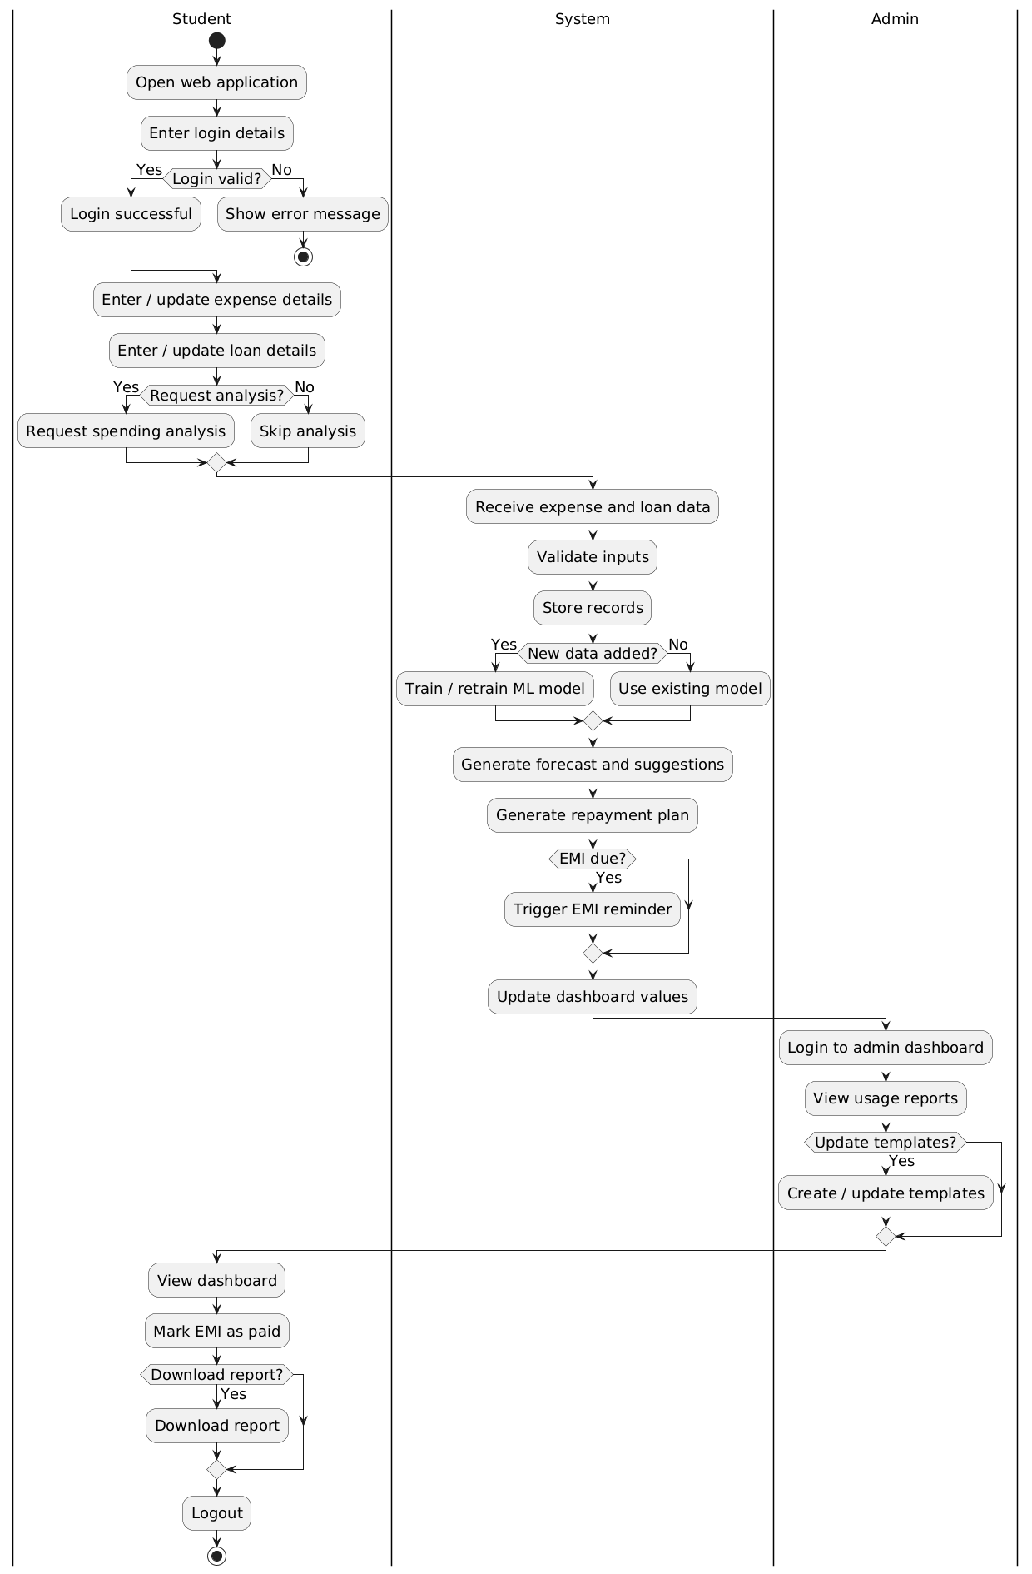
Figure.2 Activity Diagram

